Representation of Gender Prejudice in the Advertisement

As an effective medium, Public Service Advertisements (PSA) is useful for raising the public’s awareness of gender inequality. This essay will take a PSA as the case. Through the interpretation of its textual and visual elements, the portrayal of gender prejudice on women will be demonstrated.
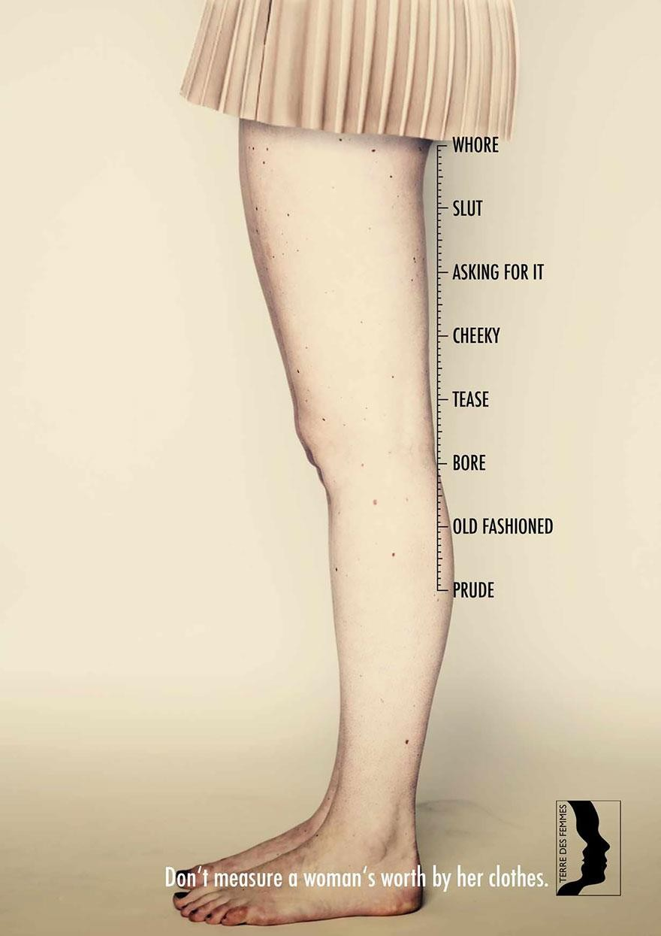

This printed advertisement attached was published on the Internet by a Swiss human rights organization named Terre Des Femmes. The whole poster comprises simple information that contributes effectively to the main theme. For images, this PSA includes two female’s legs in the middle, together with an icon beside the legs, a white headline, the organization’s logo in the right corner and a colourless background. With the biggest size, frontal horizontal shooting angle, and foregrounded and centered placement, these two legs could be considered as the salience of this advertisement. In terms of compositional information, vertically, the texts “Whole, Slut, Asking for it, Cheeky, Tease, Bore, Old fashion, Prude” are placed beside the salience; horizontally, a headline -- “Don’t measure a woman’s worth by her clothes” appears at the bottom.

First of all, designs and selections of textual elements in this advertisement successfully present the negative social status of women. According to Halliday (1986 cited in Machin, 2007, p. 47), “language provides us with resources to express kinds and levels of truth.” “Whole, Slut, Asking for it, Cheeky, Tease, Bore, Old fashion, Prude”, these words are typical adjectives and phrases used to describe women from a vicious perspective. When females dress long pants or skirts, they would be considered as “prude” and “old fashion”; when they wear something short, they would be labelled as “slut” and “whore”. It discloses a misogynistic society where women are degraded to the center of criticism. To voice for this gender inequality issue, the PSA brings forward the speech act of directive with an imperative sentence--“Don’t measure a woman’s worth by her clothes.” It addresses spectators a command, an advice and even an order to prevent themselves from measuring and criticizing females, reminding them of the unfairness of underestimating females by the length of their clothes.

In addition to textual information, visual features are concisely adopted in this advertisement, which also corresponds to the social prejudice on women. In regards of connotation carriers, the meaning of this poster is manifested from its designs of pose, shooting angle and background. Generally, body features illustrated in advertisements should be perfect (Machin, 2007). These two legs in this PSA, in comparison, are not flawless. They have moles and non-beautiful shapes, signifying they are not from a model or a star but merely an ordinary woman. By selecting these two legs as concentration, the designer articulates the commonness and truthfulness of females’ inferior status in the male- dominance society. The pose of the participant is not seductive or defiant. She seems well-behaved and stands still, indicating that she is well-educated. However, by those comments placed beside her legs, it connotes that even if a woman has no provocative behavior, there are still derogatory comments disparaging her merely by her clothes. Instead of vivid setting, the background of this PSA is dull yellow, which represents hopelessness and an unpromising mood, suggesting that females suffer chronic pains from unfair judgments. Moreover, by using frontal and horizontal angle, an intimate interpersonal connection between the advert and the audience is established. This bond directly informs the public of gender inequality issue. As a reminder, it invites viewers to ponder their own attitudes towards females in real life.

Additionally, the coherence between textual and graphic codes help audiences interpret each element. This intra-textual connection also deepens the motif of this advertisement. The verb “measure” in the headline is often defined as “to judge the quality, effect, importance, or value of something” (Cambridge, 2015). This means only objects can be judged by certain standard, though women as human beings are here considered as items. With typical features of scales and measurements, the figure beside the female’s legs is similar to a ruler. Since measuring could be conducted through a ruler, this connection between texts and images transfers this icon into a carrier of social underestimation on women, illustrating the theme and the integration of this PSA.

To conclude, this essay scrutinized the textual and graphic information of an anti-gender-prejudice PSA. The adjectives and phrases listed in the advertisement reveal the social underestimation towards women, while the headline highlights the designer’s disagreement on gender inequality. Visually, females’ adverse social position is strongly manifested by designs of the imperfect legs, the participant’s pose, the dull yellow background as well as the frontal and horizontal angle. In addition, the interconnection between the visual and textual elements deepens the theme of this PSA. With the use of ruler figure and the verb “measure”, women are here considered as objects to be judged and criticized by the public. Whilst this advertisement articulates a tendency that individuals have already been aware of the significance of gender equality, this issue is still difficult to be solved because of the long-period adoption of masculinity. Therefore, more companies and organizations should take their social responsibilities by reminding the public of this gender issue and individuals should also learn to respect women properly.

Reference:

Cambridge (2015), The Definition of ‘Measure’ [Online] Available from: http://dictionary.cambridge.org/dictionary/english/measure (Accessed: 13 Dec 2015)

Campbell, J. (1981), ‘Misogyny and homicide of women’, Advances in Nursing Science, 3(2), pp. 67–86.

Ferrant, G, & Tuccio, M (2015), 'South–South Migration and Discrimination against Women in Social Institutions: A Two-way Relationship', World Development, 72, August, pp. 240-254.

Machin, D. (2007), Introduction to Multimodal Analysis. New York: Distributed in the U.S.A. by Oxford University Press.

This advertisement is available from: http://www.boredpanda.com/dont-measure-womans-worth-

clothes-ads-terre-des-femmes/

Yeboah, T, Serbeh, R, & Bembir, P (2015), 'Omission of Men from Gender-Development Theory and Praxis: A Pathway for Addressing the Plights of Women?’ Journal Of Social Sciences / Sosyal Bilimler Dergisi, 11 (1), May, pp. 7-19. [Online] Available from: http://eds.b.ebscohost.com/eds/pdfviewer/pdfviewer?sid=17411b67-5b4f-4a19-9540-
bdd88f4f362c%40sessionmgr120&vid=2&hid=114 (Accessed: 13 December 2015)

